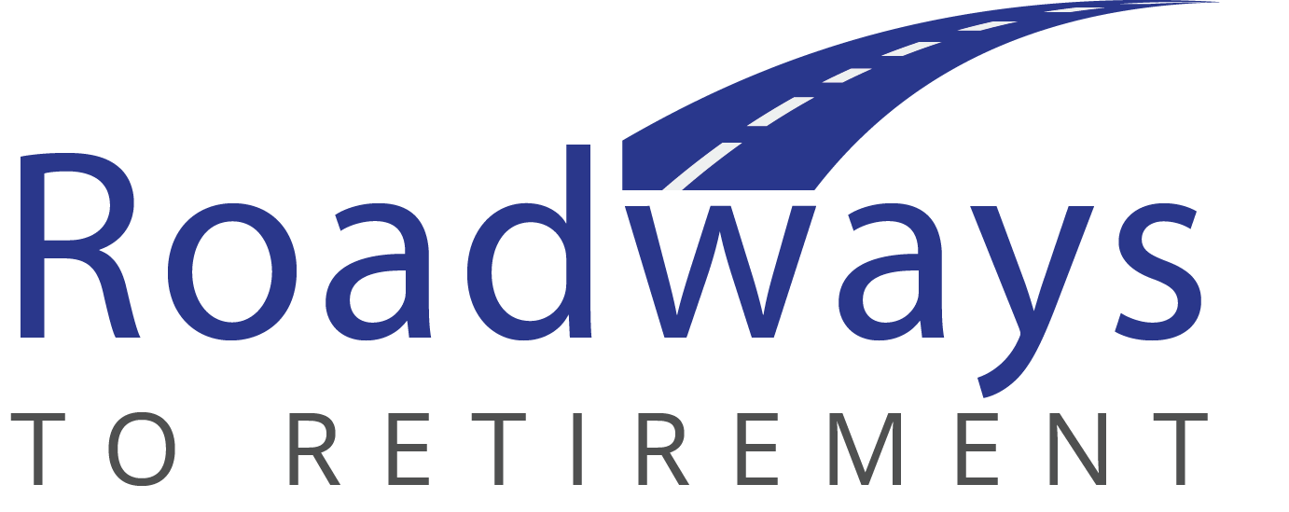

DATE

Name
Company
Address
City, State ZIP

Dear:

We were delighted to learn that you have selected the Roadways to Retirement program offered by FI Partner and BPAS as the new provider for your company’s retirement plan.

We look forward to working with you to assure a smooth conversion process in the coming weeks.
A plan conversion is a collaborative process. We’ll involve ABC Company as the plan sponsor, FI Partner as Trustee, BPAS as the new administrator, your payroll vendor (or department), and the prior administrator. Please be assured that we have successfully and seamlessly orchestrated many conversions in the past. We will do everything possible to streamline the process for your organization set the stage for a successful administrative relationship moving forward. Our dual focus will be to ensure that your Human Resources team is pleased with our program and services and ensure that your employees become truly engaged along their journey to a successful retirement.

To get the process started, please refer to the fee page in the proposal we provided for your plan. Please check the necessary boxes to indicate your elections for how certain fees should be handled, then sign and date the form. When complete, please fax it to the number indicated near the signature line to authorize us to proceed with the conversion.

Next, it would be very helpful if your Human Resources team could start gathering some key documents. Some of the documents we look for include:

- Your current plan document and adoption agreement, including amendments
- A copy of your Summary Plan Description and trust document (if applicable)
- Copies of recent Forms 5500 and attachments
- A totals page from a recent allocation report or the plan sponsor website, showing total balances by fund within the plan
- The most recent valuation report for your plan
- A copy of the most recent compliance tests performed for your plan
- A copy of your plan’s loan policy and copies of outstanding amortization schedules (if available)
- Listing of distributions for the current and prior year (if available)
- Optional: credentials to your current plan sponsor website so we can help collect much of the data we’ll need
These documents can be provided to us in hard-copy form, or through a secure web upload provided by BPAS – whatever is easiest for you.

I will call you in the next few days to discuss the next steps and set a date for our kick-off meeting so we can talk about any plan design changes you would like to make as well as to finalize the new investment menu. We will also review the conversion process as a whole and set a strategy for enrollment meetings. We will have a few questions during the process, but please be assured it will be an easy transition for you and your employees.

Again, thank you for the confidence you have placed in FI Parter and BPAS. Our commitment is to ensure that when you look back at this time several years from now, you will conclude that choosing Roadways to Retirement was one of the best moves your plan has ever made.

Sincerely,

